

Societal Internship Report

On

Sahara Initiative

**Submitted By: Guided By:**

* Rishi Nanda(24162582017)
* Patel Jeal(24162172009)
* Patel Vishva(24162172012)
* Vadechiya Nisarg(24162172004)
* Lunechiya Aryan(24162582016)
* Contractor Heet(24162582003)
* Modi Subham(24162582019)
* Agrawal Jayesh(24162582006)

**Submitted to**

**Computer Science & Engineering Department Institute of Computer Technology**

**Ganpat University Year: 2024**

# CERTIFICATE

This is to certify that the report by **Rishi Nanda**, **Patel Jeal**, **Patel Vishva**, **Vadechiya Nisarg**, **Lunechiya Aryan**, **Contractor Heet**, **Modi Subham**, and **Agrawal Jayesh** of Ganpat University, towards the fulfillment of the degree of Bachelor of Technology – Computer Science and Engineering, is a record of Societal Internship, carried out in the CSE Department.

**Signature of HOD: Signature of Internal Guide:**

____________________ ____________________

_____________

(Office Seal)

**Place:** Ganpat University

# Date:

**Details of Work Done**

**Day-1**

* **Group 1**

Members :-

* + 1. Patel Vishva
    2. Contractor Heet
    3. Agrawal Jayesh

Address :- Sheh Kutir Old Age Home, near Nilkanth Mahadev Temple, Nagalpur Part, Mehsana, Gujarat 384002

Reg. No :- E/3478-Mehsana

Contact No :- 9426746462

Website :- N/A

Details :- The old age home has been operational for 15. There are 70 Elders with 7 Staff.

Requirement :- Need Staff Room, Whichever type of oil Doner are willing to supply (Monthly they require 6 cans)

Photos :-

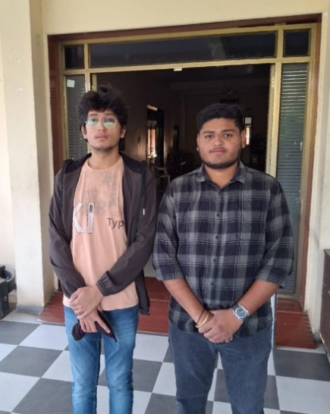

* **Group 2**

Members :-

1. Patel Jeal
2. Vadechiya Nisarg
3. Lunechiya Aryan
4. Modi Subham

Address :- 5CVP+3CH, Tirupati Rajnagar, Palanpur, Gujarat – 385001

Reg No:- E/1042/B.K

Contact No :- 9824014091

Details :- This ashram has been operating for 35 years and houses 18 elderly residents. They provide free food, clothing, and medical support.

Requirement :- ₹1.15 lakh for groceries (monthly)

Photos:-

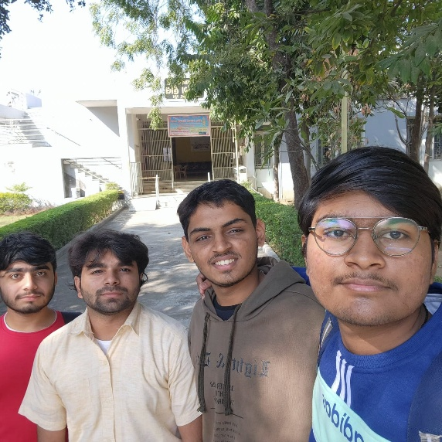

* **Group 3**

Members :-

1. Rishi Nanda

Address :- 18-30, Nikol - Naroda Rd, Nikol Gam, Ahmedabad, Gujarat - 382350

Reg. No :- F-14979

Contact No :- 9426529485

Details :- Established 9 years ago, Bhojalram Senior Citizen Mandal requires wheelchairs and toilet chairs.

Requirement :- **10 Wheelchairs,2 Toilet chairs**

Photos:-

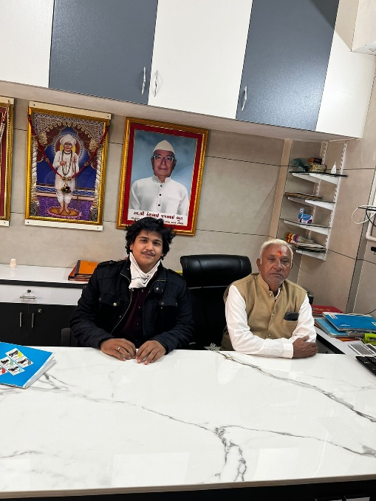

**Day-2**

* **Group 1**

Members :-

1. Patel Vishva
2. Contractor Heet
3. Agrawal Jayesh

Address :- Anandi Ma No Vadlo, Mansa - Badpura Rd, Mansa, Gujarat 382845

Reg. No :- E-1365/Gandhinagar

Contact No :- 9978405372

Website :- N/A

Details :-

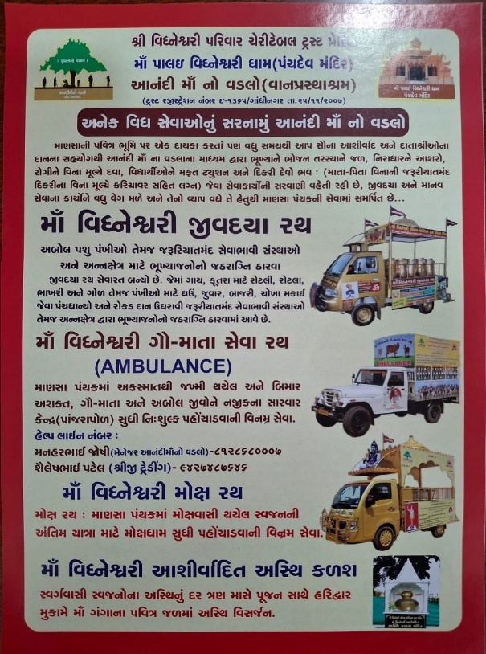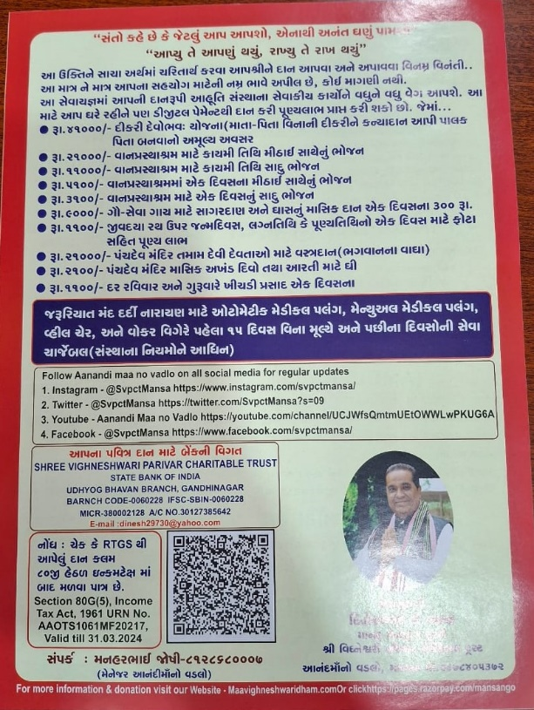

Requirement :-

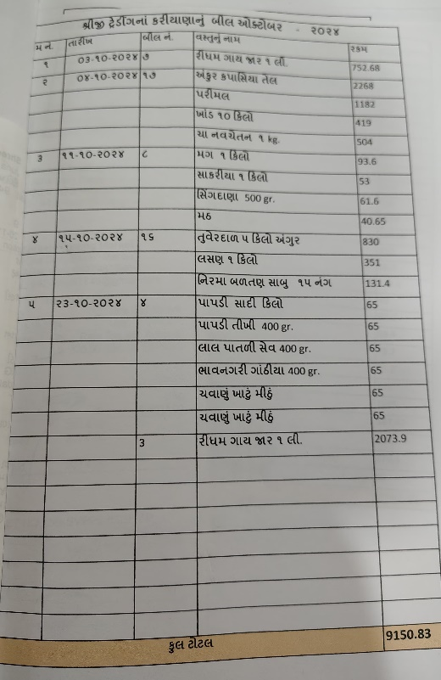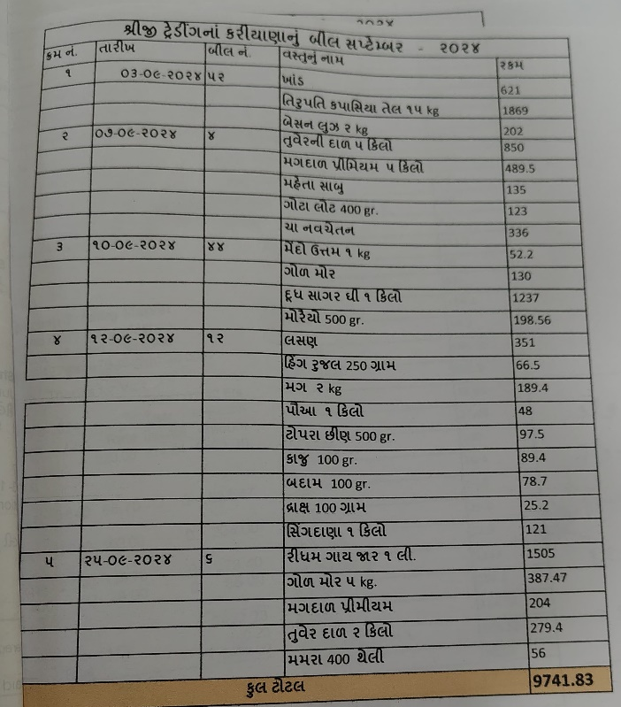

Photos :-

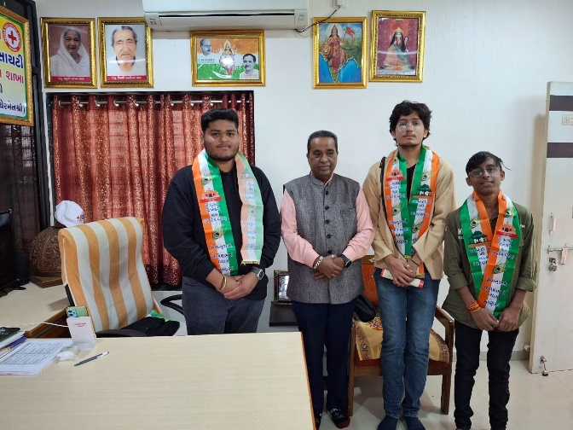

* **Group 2**

Members :-

1. Patel Jeal
2. Vadechiya Nisarg
3. Lunechiya Aryan
4. Modi Subham

Address :- R927+W6C, Patan Road, Unjha, Gujarat - 384170

Reg. No :- E/1344

Contact No :- 9879582883

Details :- The old age home in Unjha has been operational for 35 years and currently houses 18 elderly residents. All services, including clothing and medicines, are provided free of cost. The facility focuses on ensuring the well-being and comfort of its residents by addressing their essential needs.

Requirement :-

* Medicines and painkillers
* Hot water bags / body warmers (for muscle relaxation)

Photos :-

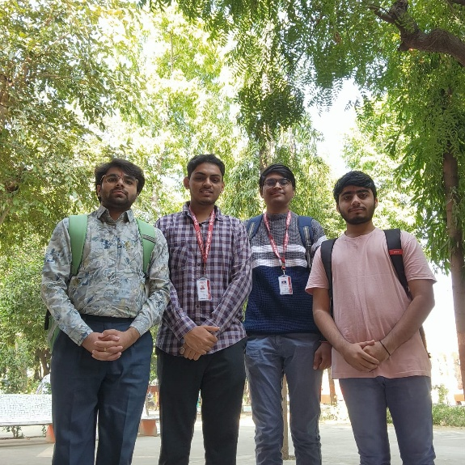

* **Group 3**

Members :-

1. Rishi Nanda

Address :- Karai, Canal Road, Ahmedabad, Gujarat - 382330

Contact No :- 9313581114

Details :- SSD Sukhdham is a newly built ashram requiring food, grains, and groceries for daily operations.

Requirement :- Food and grains

Photos :-

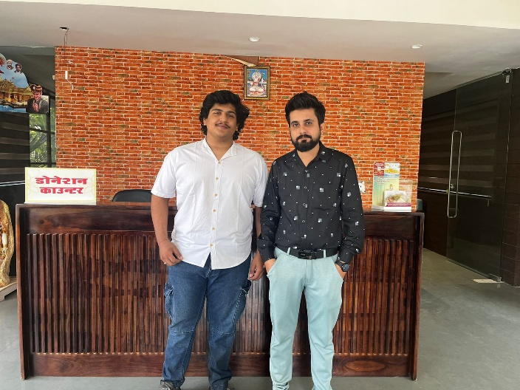

**Day-3**

* **Group 1**

Members :-

1. Patel Vishva
2. Contractor Heet
3. Agrawal Jayesh

Address :- Senior citizen park Shree Ram Foundation, Vasai, Gujarat 382865

Reg. No :- E/ 12881 Mehsana

Contact No :- 98731 09906, 98250 48556

Website :- N/A

Requirement :-

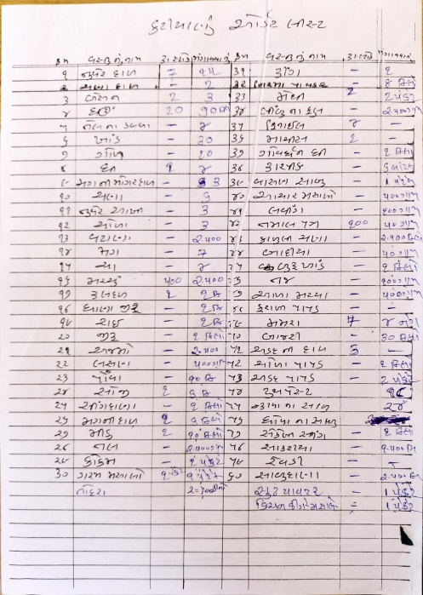

Photos :-

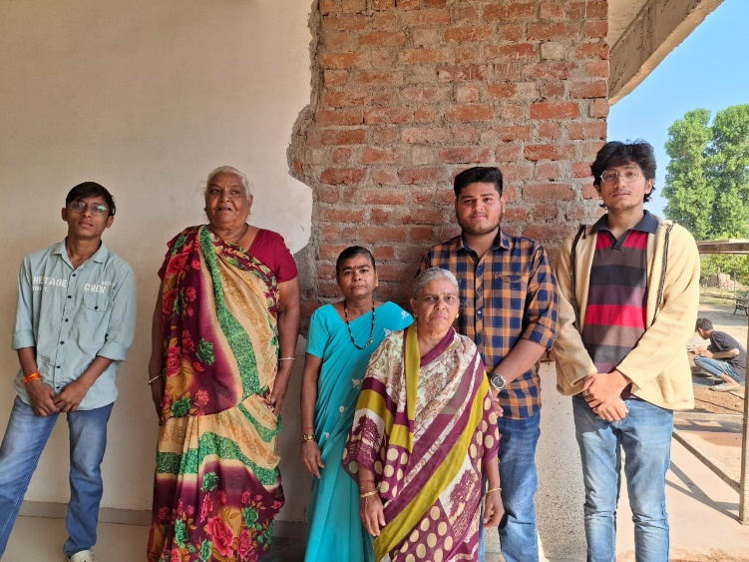 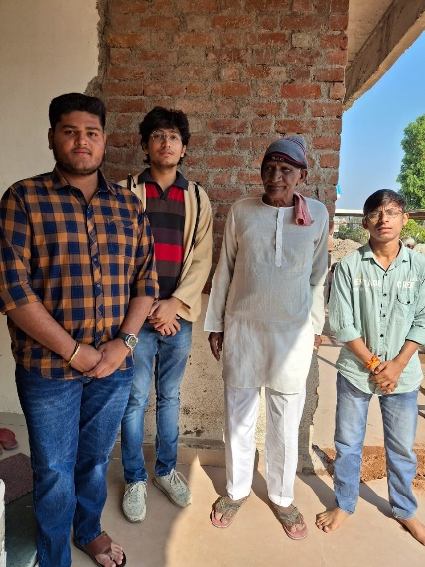

* **Group 2**

Members :-

1. Patel Jeal
2. Vadechiya Nisarg
3. Lunechiya Aryan
4. Modi Subham

Address :- Honesty Society, Dharnat Mohalla, Rajpur, Siddhpur, Gujarat – 384151

Contact No :- 9228503570

Details :- The ashram was founded 100 years ago but developed into a structured old age home 15 years ago. It also serves as a bhakti ashram where elderly residents engage in spiritual practices.

Requirement :- Groceries

Photos :-

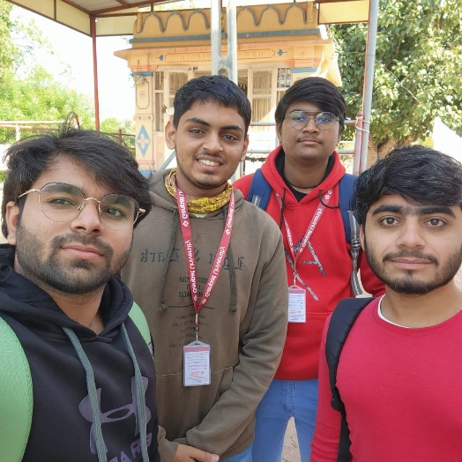

* **Group 3**

Members :-

1. Rishi Nanda

Address :- Motera, Ashram Road, Ahmedabad, Gujarat

Details :- This ashram did not express any specific requirements during our visit. A resident had recently passed away, so inquiries were limited.

Photos :-

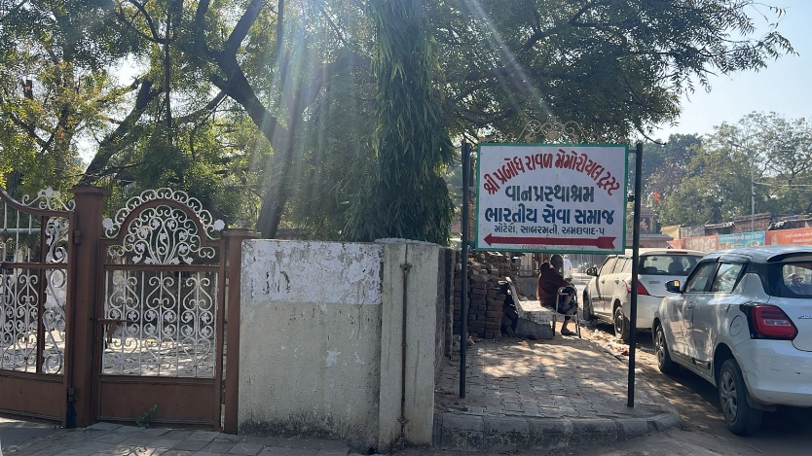

**Day-4**

**Krishnadham Vrudhashram**

* **Group**

Members :-

1. Patel Vishva
2. Contractor Heet
3. Agrawal Jayesh
4. Patel Jeal
5. Vadechiya Nisarg
6. Lunechiya Aryan
7. Modi Subham
8. Rishi Nanda

Address :- Krishnadham Vrudhashram, Before Just, 3 Chaitanya Society, Between Vastrapur Gam Bus Stand, IIM Road, Ahmedabad, Gujarat - 380015

Reg. No :- E/21547/Ahmedabad

Contact No :- 9723282541

Website :- [www.krishnadhamoldagehome.in](http://www.krishnadhamoldagehome.in)

Details :- Krishnadham Vrudhashram is home to 15 elderly members and 5 staff members. The facility is self-sufficient and has no specific requirements. Vishal Goyal, the owner, efficiently manages the operations.

Requirement :- No specific requirements as the facility is well-funded.

Photos :-

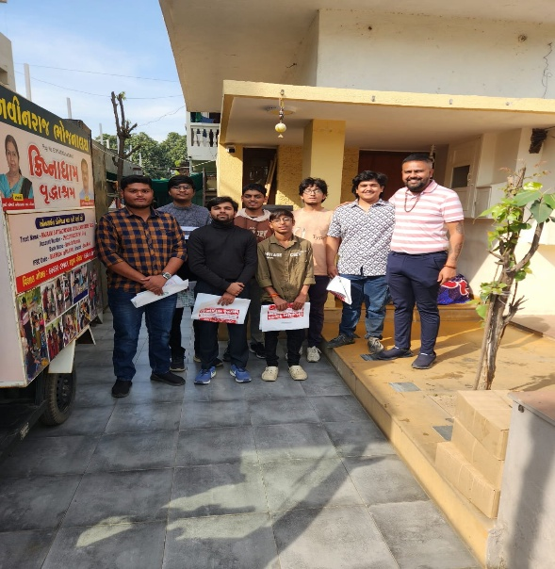

**Day-5**

**Matoshree Vrudhashram**

* **Group**

Members :-

1. Patel Vishva
2. Contractor Heet
3. Agrawal Jayesh
4. Patel Jeal
5. Vadechiya Nisarg
6. Lunechiya Aryan
7. Modi Subham
8. Rishi Nanda

Address :- 25 Vandana Park Society, Chandlodiya Road, Nava Vadaj, Ahmedabad, Gujarat - 380013

Reg. No :- F/21082/Ahmedabad

Contact No :- 9714752172, 9586925737

Website :- [www.ajct.in](http://www.ajct.in)

Details :- Matoshree Vrudhashram houses 23 residents and 5 staff members. Their primary requirements are financial assistance for rent (₹1 lakh per month) and groceries. Food costs ₹7700 per day. They do not admit handicapped individuals and focus on caring for elderly residents who are physically fit.

Requirement :-

* ₹1 lakh for rent (monthly)
* Groceries

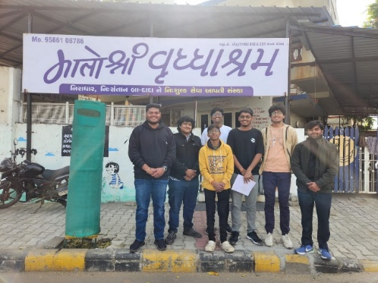 Photos :-

**Day-6**

**Aastha Foundation**

* **Group**

Members :-

1. Patel Vishva
2. Contractor Heet
3. Agrawal Jayesh
4. Patel Jeal
5. Vadechiya Nisarg
6. Lunechiya Aryan
7. Modi Subham
8. Rishi Nanda

Address :- L-12, Swatantra Senani Society, Nava Vadaj, Ahmedabad, Gujarat - 380013

Contact No :- 9998096016

Website :- [www.aastha.foundation.com](http://www.aastha.foundation.com)

Details :- The foundation accommodates 25 elderly members and has 3 staff members. Due to privacy concerns, limited information was provided. They maintain connections with the Karma Foundation but expressed no specific requirements during the visit.

Requirement :- No specific requirements.

Photos :-

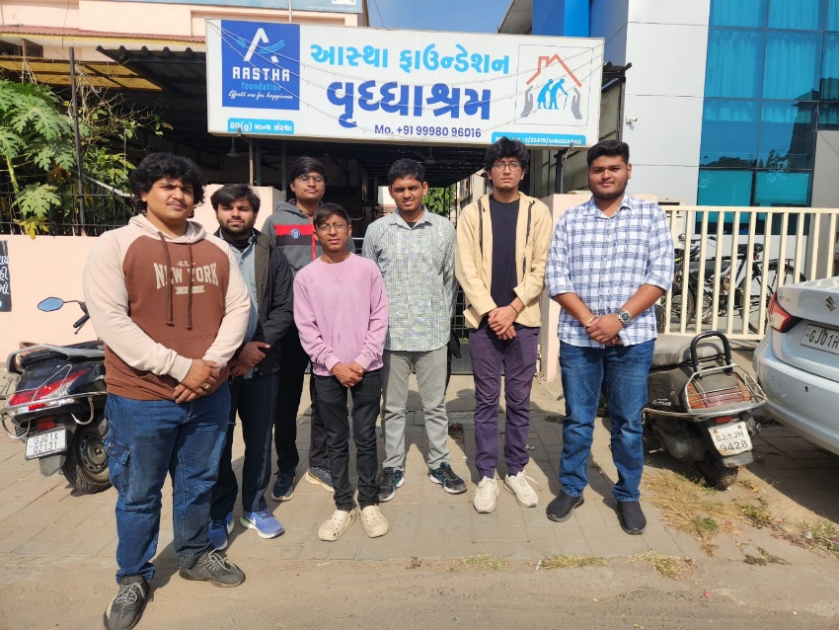

**Day-7**

**Visaamo Vrudhashram**

* **Group**

Members :-

1. Patel Vishva
2. Contractor Heet
3. Agrawal Jayesh
4. Patel Jeal
5. Vadechiya Nisarg
6. Lunechiya Aryan
7. Modi Subham
8. Rishi Nanda

Address :- 21, 22, New Man Mandir Society, Vejalpur, Ahmedabad, Gujarat - 380051

Reg. No :- F/21617/Ahmedabad

Contact No :- 7016755992, 9104510046

Website :- [www.shreecharitabletrust.org](http://www.shreecharitabletrust.org)

Details :- Visaamo Vrudhashram houses 14 residents, many in critical conditions such as paralysis. Managed by Nimishaben Vyas, they require hand gloves and diapers for the elderly.

Requirement :-

* Hand gloves
* Diapers

Photos :-

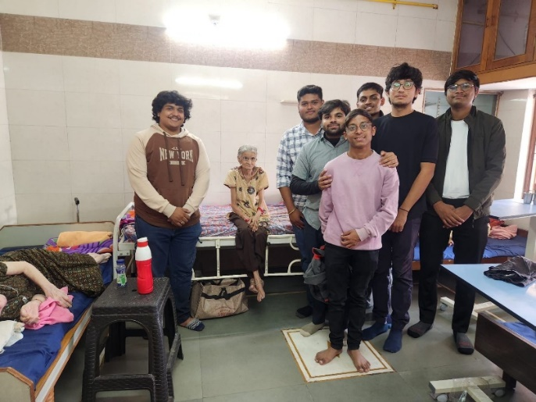

**Day-8**

**Karmayog Foundation (Vrudhaashram)**

* **Group**

Members :-

1. Patel Vishva
2. Contractor Heet
3. Agrawal Jayesh
4. Patel Jeal
5. Vadechiya Nisarg
6. Lunechiya Aryan
7. Modi Subham
8. Rishi Nanda

Address :- 1, Samadhaan Society, Ranip, Ahmedabad, Gujarat - 382480

Reg. No :- A-5056/Ahmedabad

Contact No :- 7600762900

Website :- [www.karmyogfoundation.com](http://www.karmyogfoundation.com)

Details :- The foundation supports 27 elderly members with 8 staff. They conduct health checkups, organize trips to Dwarka and Somnath, and have Maa Amrutam cards for free hospital treatments.

Requirement :-

* Financial assistance
* Groceries

Photos :-

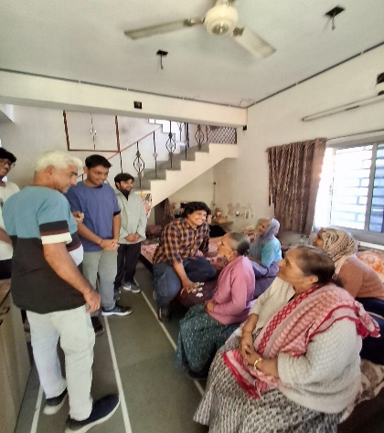

**Day-9**

**Jivan Sandhya Vrudhashram**

* **Group**

Members :-

1. Patel Vishva
2. Contractor Heet
3. Agrawal Jayesh
4. Patel Jeal
5. Vadechiya Nisarg
6. Lunechiya Aryan
7. Modi Subham
8. Rishi Nanda

Address :- 132 Feet Ring Road, Narayanpura, Ahmedabad, Gujarat – 380013

Details :- This old age home admits only fit elderly individuals. Due to privacy concerns, visits were restricted. They require tea packets and oil

tanks for food preparation.

Requirement :-

* Tea packets
* Oil tanks

Photos :-

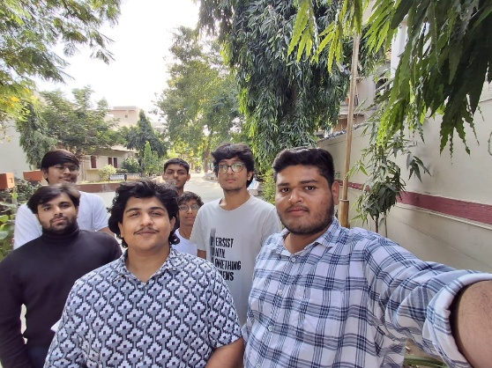

**Day-10**

**Shree Ram Charitable Trust Old Age Home**

* **Group**

Members :-

1. Patel Vishva
2. Contractor Heet
3. Agrawal Jayesh
4. Patel Jeal
5. Vadechiya Nisarg
6. Lunechiya Aryan
7. Modi Subham
8. Rishi Nanda

Address :- Shree Ram Charitable Trust Old Age Home

Reg. No :- E/12881 (Since 2000)

Contact No :- 9825048556

Details :- The trust accommodates elderly individuals who suffer from chronic body pain. Their primary requirement is Zandu Balm to alleviate muscle pain.

Requirement :-

* Zandu Balm

Photos :-

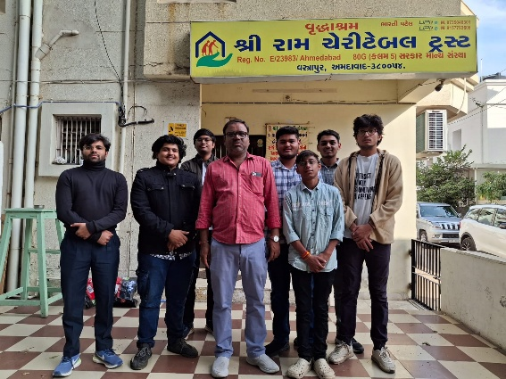

# 

# Experience Sharing and Life Lessons Learned

Through this internship, we observed the different approaches adopted by old age homes to support the elderly. We learned the importance of empathy, compassion, and the role of organizations in addressing societal challenges. Managing resources and ensuring health care are key responsibilities in these facilities.

This experience has taught us the significance of giving back to society and understanding the needs of marginalized communities like senior citizens.

## Suggestions and Future Extensions

* **Financial Support:** Encourage fundraising initiatives to meet daily operational costs like rent, groceries, and medical supplies.
* **Awareness Programs:** Promote campaigns to raise awareness about elderly care and support.
* **Volunteering Programs:** Encourage students and individuals to volunteer at these old age homes.
* **Medical Assistance:** Collaborate with local hospitals to provide free health checkups and medicines.